  National Assembly | 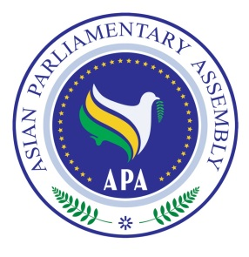  ASIAN PARLIAMENTARY ASSEMBLY  1st Executive Council Meeting  01-04 October 2017  Phnom Penh, Kingdom of Cambodia  4

REGISTRATION FORM

Please fill in one form for each participating delegate in CAPITAL letters, and return by 20 September 2017

Delegation of: ………………………………
Name of Parliament

Title: Mr. Ms. Dr.
First Name:
Last Name:

Position: …………………………………… Head of delegation Member of delegation
- Please indicate if you are the Head of delegation
Passport No: Date of birth (d/m/y) Place of birth (City, Country)

………………………..…

Passport issue date: Passport expiry date: Place of visa issuance (City, Country)

……………………………….

Tel No. | …………………..……………………………………………..  Country Code - City Code - Number
Mobile No.
Fax No.
Email Address:
Flight Details

 | Date | Airline & Flight number | Time | Explanation
Arrival
Departure
Please forward (fax or e-mail) the completed form to both the Host Secretariat as well as CC to the APA Secretariat:

Host Secretariat:
Email: thulheang@gmail.com
CC to APA Secretariat:
Email :secretariat@asianparliament.org
Fax : (+98-21) 26118809
Phone : (+98-21) 26118827
26118829
26118869

hokcscc@yahoo.com
cambodia_apagroup@yahoo.com

Fax : (855-23) 218 195
Tel : (855-23) 218 195
HP : (855-12) 761 666
: (855-12) 855 789

National Assembly | ASIAN PARLIAMENTARY ASSEMBLY  1st Executive Council Meeting  01-04 October 2017  Phnom Penh, Kingdom of Cambodia  4

TO FACILITATE OUR PREPARATIONS TO ISSUE THE IDENTIFICATION BADGES PLEASE COMPLETE AND RETURN THIS FORM TOGETHER WITH THE REGISTRATION FORM

No. | First Name | Last Name | Position in Parliament | Position in Delegation

